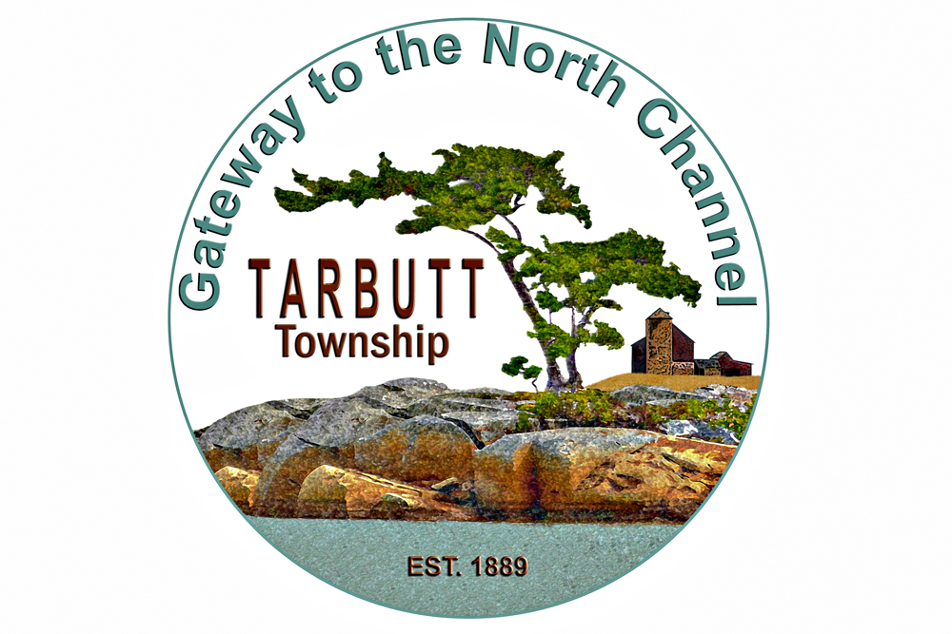
Accessible Customer Service Feedback Form

Thank you for visiting Township of Tarbutt. We value all of our customers and strive to meet everyone’s needs. Your feedback is important to us.

To help us better serve you by providing fully Accessible Customer Service, please complete our feedback form using this form or asking us for the form in alternative formats.

Did we respond to your customer service needs today? YES NO

Was our customer service provided to you in an accessible manner?
YES SOMEWHAT NO (please explain below)

Did you have any problems accessing our goods and services?
YES (please explain below) SOMEWHAT (please explain below) NO

Please add any other comments you may have:

Contact information (optional):

Thank you.
This document is available in alternative formats or visit our website to complete an online survey.

Township of Tarbutt
27 Barr Rd. S. RR # 1 Desbarats, ON. POR 1E0
Phone: 705-782-6776 * Fax: 705-782-4274 * Email: tarbutttownship@bellnet.ca
www.tarbutt.ca

