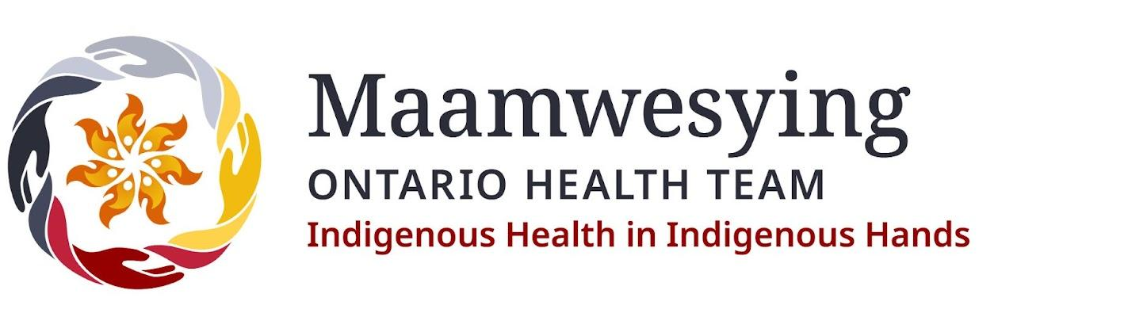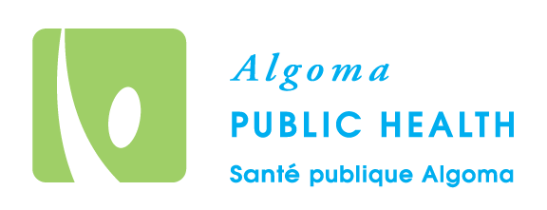
For Immediate Release
April 2, 2024

Maamwesying Ontario Health Team and Algoma Public Health Sign Collaboration Agreement

Maamwesying North Shore Community Health Services Inc., as a core partner of the Maamwesying Ontario Health Team, and Algoma Public Health, held a signing ceremony on March 27th at the Sault Ste. Marie Community Room at Algoma Public Health. This agreement is for Indigenous peoples by embracing their unique cultural knowledge, and traditional practices and improving access to and awareness of Indigenous Health Services available in the Northeast region.

The Maamwesying Ontario Health Team was announced in October of 2022 to seamlessly integrate health care services for clients in the communities of Atikameksheng Anishnawbek, Sagamok Anishnawbek, Serpent River First Nation, Mississauga First Nation, Thessalon First Nation, Garden River First Nation, Batchewana First Nation, Michipicoten First Nation, Chapleau Cree First Nation, Chapleau Ojibwe First Nation, and Brunswick House First Nation, as well as the urban Indigenous population in Sault Ste. Marie.

"In solidifying this partnership, the Maamwesying Ontario Health Team and Algoma Public Health emphasize the pivotal role of Indigenous-led healthcare systems characterized by community-driven innovation and cultural sensitivity. This agreement reinforces the value of Indigenous communities, acknowledging their right to self-determination in the healthcare landscape. Collectively, our vision aligns with creating a healthcare system free of racism and discrimination, shaping a future where health equity prevails," said Carol Eshkakogan, Chief Executive Officer of Maamwesying North Shore Community Health Services Inc. and Chair of the Maamwesying Ontario Health Team Leadership Council.

The collaboration between Maamwesying Ontario Health Team and Algoma Public Health is driven by a vision to provide coordinated and seamless health care, ensuring optimal outcomes for Indigenous patients, clients, and communities. This collaboration aims to improve access to quality care to improve outcomes and enhance patient care that is equitable and culturally safe, while actively involving Indigenous health leaders and advisors in the planning, design, delivery, and evaluation of public health services to enhance the satisfaction and experience for patients, caregivers, and providers.

“Algoma Public Health is honoured to become a collaborative partner to walk alongside Maamwesing in the spirit of Truth and Reconciliation,” said Dr. Jennifer Loo, Medical Officer of Health and CEO of Algoma Public Health. “Maamwesying’s leadership demonstrates the importance of self-determination and placing Indigenous health in Indigenous hands. Working together, we can pool our collective strengths to advance health promotion, protection against disease and injury, and embrace inclusive strategies to prioritize health equity for all.”

By signing this agreement, Maamwesying Ontario Health Team and Algoma Public Health are committing to work together to create culturally safe spaces within the healthcare system and support the design and delivery of public health programs and services so Indigenous patients have the support they need to access the right care at the right time.

Media Contacts:
Grace Swain
Communications and Media Specialist
Maamwesying Ontario Health Team
grace.swain@nmninoeyaa.ca

Leonardo Vecchio

Algoma Public Health
Communications
communications@algomapublichealth.com

